**Scope**: To find non-ML ways to enhance elevation gradients in DSM to better represent inner edges.

**Background and evidence of effectiveness:**

Knowing DSM is rich in representing elevation gradients and the changes in which can represent roof ridges and junctions between the ridges.

Non – ML: Difficulty in annotation and foe streamlined pipeline which can later be incorporated in the post-processing of the segmentation output of the inner-edges model.

**Experiments till now**

**Gradient Analysis:**

Picking gradients in both X and Y direction going up to the second order using Laplacian.

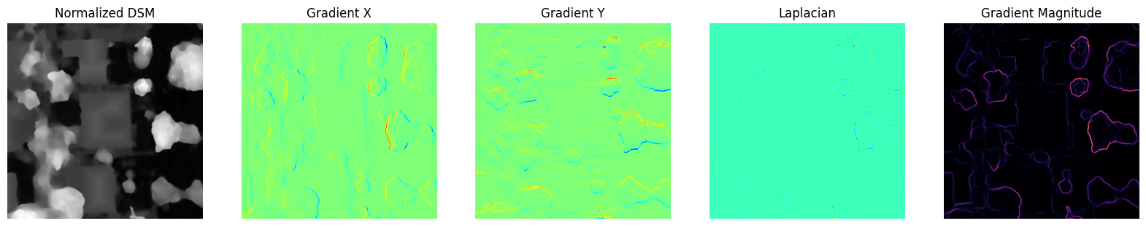

The Laplacian gives no useful results while the gradient magnitude seems to preserve everything but the house.